Select any 10 Dua’s from Holy Quran that have been taught during classes and

explain their concept and impact on our daily life.

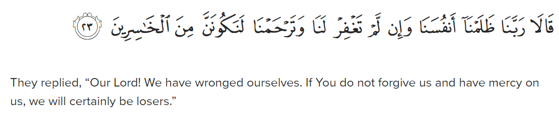

Surah Al-A'raf 7:23

This verse speaks about seeking refuge in Allah from the whispers of Satan. The impact of reciting this Dua is immense in protecting oneself from evil thoughts and influences in daily life.

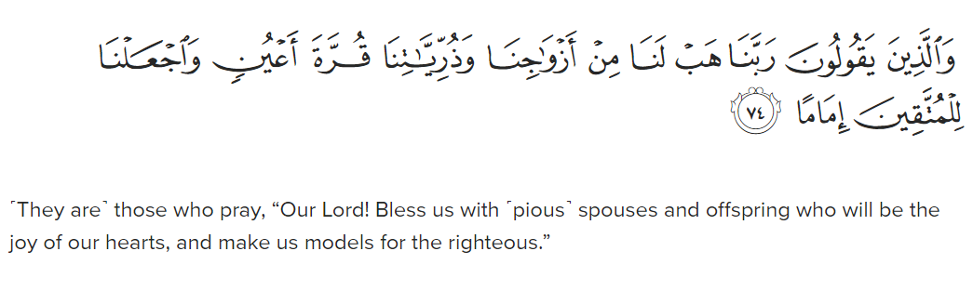

Surah Al-Furqan 25:74

Here, believers are instructed to pray for themselves and their families to be a source of comfort and strength. This Dua emphasizes the importance of family unity and support in facing life's challenges.

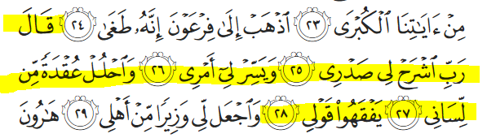

Moses prayed, “My Lord! Uplift my heart for me, and make my task easy, and remove the impediment from my tongue so people may understand my speech.

Surah Taha 20:25-28

Moses's Dua for eloquence and support from Allah when facing Pharaoh highlights the importance of seeking divine assistance in difficult situations. It teaches us to rely on Allah's guidance and help in overcoming obstacles.

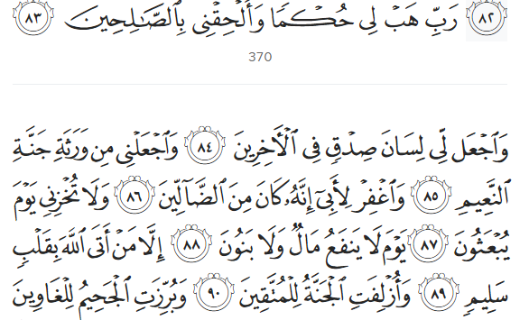

“My Lord! Grant me wisdom, and join me with the righteous. Bless me with honourable mention among later generations. Make me one of those awarded the Garden of Bliss. Forgive my father, for he is certainly one of the misguided. And do not disgrace me on the Day all will be resurrected—the Day when neither wealth nor children will be of any benefit. Only those who come before Allah with a pure heart ˹will be saved˺.”

Surah Ash-Shu'ara 26:83-89

Prophet Ibrahim's prayer for forgiveness and acceptance of his efforts is a powerful reminder of humility and repentance. This Dua encourages believers to seek forgiveness and mercy from Allah regularly.

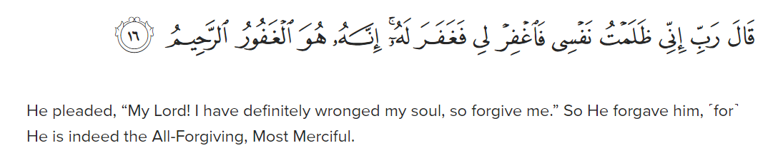

Surah Al-Qasas 28:16

Moses's supplication for ease in his affairs and removal of his burdens teaches us to turn to Allah in times of distress and seek His help in solving our problems.

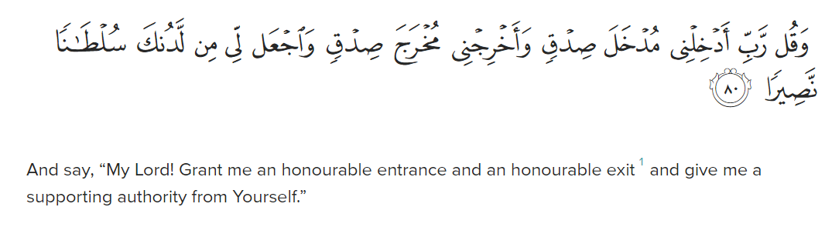

Surah Al-Isra 17:80

Prophet Ibrahim's prayer for Allah to grant him and his descendants the ability to establish prayers emphasizes the significance of maintaining regular prayer and devotion in daily life.

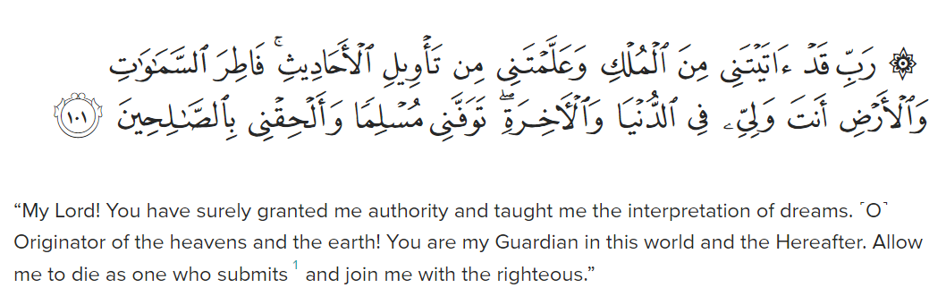

Surah Yusuf 12:101

This verse highlights Prophet Yusuf's Dua for a noble death and to be among the righteous. It reminds us of the importance of leading a righteous life and seeking a good end in this world and the Hereafter.

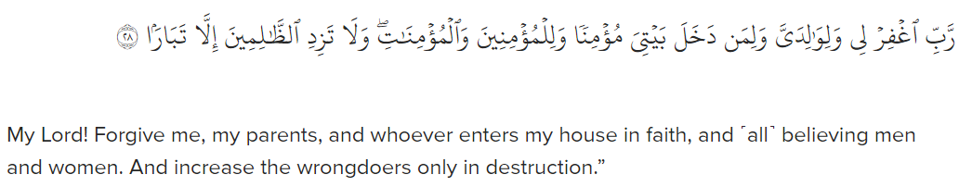

Surah Nuh 71:28

Prophet Nuh's supplication for forgiveness for himself, his parents, and all believers showcases the importance of interceding for others and seeking forgiveness for all members of the community.

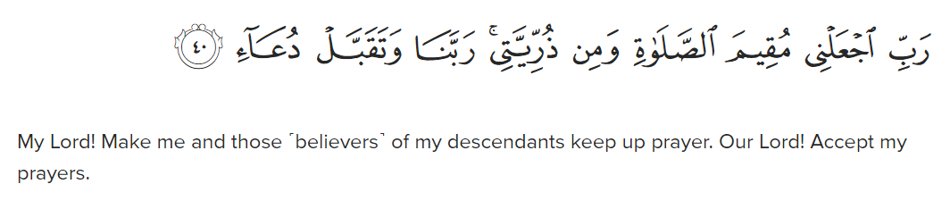

Surah Ibrahim 14:40

Here, Prophet Ibrahim's Dua for protection against the punishment of Hellfire underscores the significance of seeking refuge in Allah from the consequences of wrongdoing and sin.

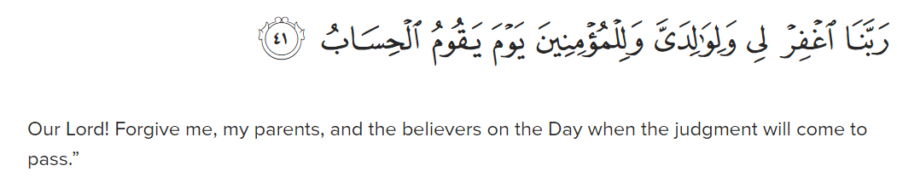

Surah Ibrahim 14:41

Ibrahim's prayer for forgiveness for himself, his parents, and all believers highlights the concept of seeking forgiveness not only for oneself but also for others, including loved ones and the broader community.

These Duas from the Holy Quran provide guidance and inspiration for believers to strengthen their relationship with Allah, seek His help in times of need, and strive for righteousness in their daily lives. They serve as a reminder of the importance of humility, gratitude, and seeking forgiveness as integral aspects of faith and spiritual growth.